Query:

select to_char(date '1947-08-15','month ddth day year') from dual;

Result:



Query:

select months_between(sysdate,date '1997-10-07') from dual;



Query:

select

substr('sai hemanth kotturi', 1, instr('sai hemanth kotturi', ' ')-1) AS col1,

substr( 'sai hemanth kotturi ', instr('sai hemanth koturi',' ')+1, instr('sai hemanth kotturi',' ',1,2)-instr('sai hemanth kotturi',' ')-1 ) as col2,

substr('sai hemanth kotturi',instr('sai hemanth kotturi', ' ',1,2)) AS col3

FROM dual;

Result:



Decode:

Query:

select ename ,

DECODE(deptno, 10, 'Accounting',

20, 'Research',

30, 'Sales',

40, 'Operations') Department from emp;

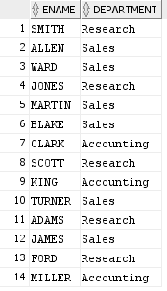

Query:

Select ename,TO_CHAR(HIREDATE,'"hired on" Ddspth "of" fmMonth,YYYY "at" Hh:mi:ss') formatted from emp

Result:

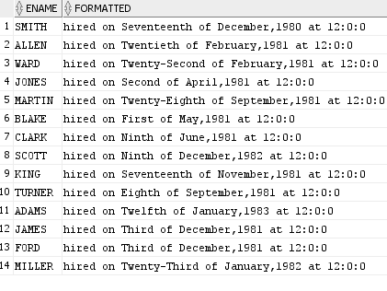

Query:

select to_char(to_date('30-may-2021'),'Day') from dual



String functions:

Query:

select instr('telangana lock down ','an',3,2) from dual;

result:



Query:

select last_day(sysdate) from dual;

